07.04.2020.

- Watch the video below and write down the vocabulary mentioned in the video, along with one sentence English definitions. You should have eleven words/expressions on your list.

https://www.youtube.com/watch?v=uOgs3jfiYwc

- Watch the video below and write at least six sentences about the Easter traditions in the five mentioned countries.

https://www.youtube.com/watch?v=HMDNCfl4Pxw

HAPPYY EASTER! HAPPY EASTER! HAPPY EASTER!

- EXTRA TASK:
Coronavirus in Great Britain – listening practice.
Watch the attached video about the newest regulations which were announced by the British Prime Minister on 24th March 2020 and answer the questions below.
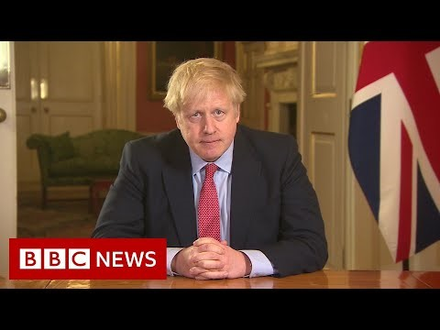

1. What are the new restrictions and how they may affect people's everyday lives?
2. What is the Prime Minister Boris Johnson encouraging people to do?
3. Why has the British government drastically changed the approach of fighting with the coronavirus?
4. What do British people think about new regulations?
5. What is Daniel Sandford Home Affairs Correspondent is talking about in the video?
6. What places can and cannot the British visit and go to now?
7. What is the government doing to help the businesses?
8. What is Emma Simpson the Business Correspondent talking about the trains and the underground?
9. How many people can an individual infect within 5 days?
10. What is your opinion about the new restrictions in Great Britain?

H A P P Y E A S T E R ! ! ! H A P P Y E A S T E R ! ! !

ŹRÓDŁO: w w w . e l i k e e n g l i s h . p l

